To Those I Love and
To Those Who Love Me

When I am gone release me; let me go.
I have so many things to see and do.
You must not tie yourself to me with tears,
Be happy that we had so many years.
I gave you my love – you can only guess
How much you gave me in happiness.
I thank you for the love you each have shown.
But now it is time I traveled on alone.
So, grieve awhile for me, if grieve you must;
Then let your grief be comforted by trust.
It’s only for a while that we must part,
So bless the memories within your heart.
I won’t be far away, for life goes on.
So if you need me, call. I will come.
Though you can’t see me or touch me, I’ll be near;
And if you listen with your heart you will hear
All of my love around you, soft and clear.
And then, when you must come this way alone,
I’ll greet you with a smile and say
“Welcome Home.”


Services Entrusted To:



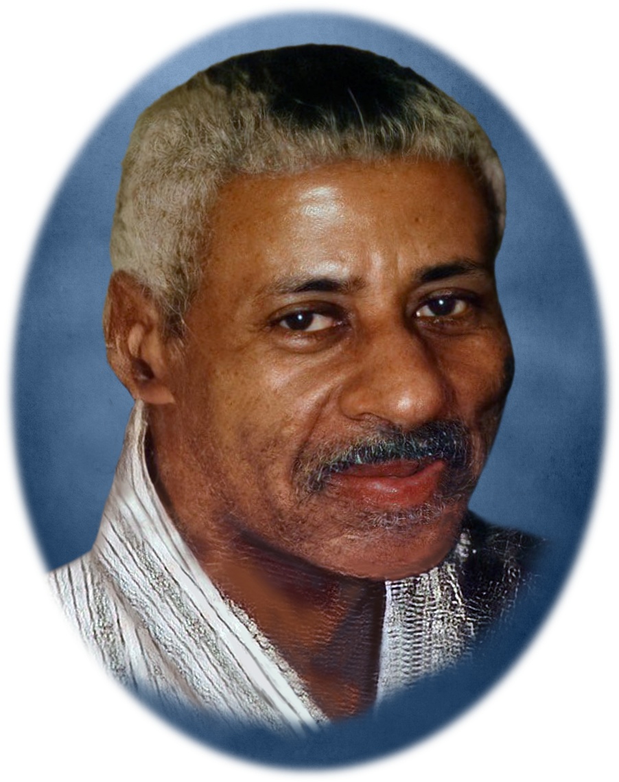

Mr. Burroughs Vereen, Jr.

Obituary

Mr. Burroughs Vereen, Jr. was born on July 11, 1947, in Aynor, South Carolina. He was the son of Burroughs and Sarah Virginia Vereen. He went home to be with the Lord on Sunday, September 19, 2021.

Burroughs was educated in the public schools of Horry County, SC and graduated from Whittemore High School in 1965. Burris was a standout basketball player, and was well known for his sharp shooting. He married his beloved Joy in 1976.

A dedicated and passionate professional, Burroughs B.J. Vereen valued an honest day's work. B.J. was well known for his unwavering work ethic, supporting Myrtle Beach’s largest and most successful newspaper, The Sun News. Prior to starting his own business venture, Vereen’s Janitorial Service, B.J. served in a critical role at the award winning Carolina Opry.

He was preceded in death by: his parents, Burroughs and Sarah Virginia Vereen, his wife, Joy Vereen; and sisters, Willie Mae, Bertha Lee, and Donnis.

Mr. Burroughs Vereen, Jr. leaves to mourn his passing: his sons, Carey (Olga) Vereen, of Reston, Virginia; Mike Vereen, of Columbia, South Carolina; Marcus Vereen, of Columbia, South Carolina, and Pastor BJ (Shannon) Vereen, of Florence, South Carolina; sisters, Helen and Roggie Lee; brother, Jimmy. He was Pepaw to 14 grandchildren, and leaves behind many beloved nieces and nephews.

Graveside Service

Wednesday, September 29, 2021 – 11:00 a.m.

Lincoln Cemetery

4900 Farrow Road

Columbia, South Carolina

Call to Worship
Prayer of Comfort………………………………………..Billy Coker
Old Testament - 3:1-8 Ecclesiastes 3:1-8………............Jadin Vereen
New Testament – 1 Thessalonians 4:14-17…………...Sonja Barkley
A Time of Remembrance……………………..……... Rosalind Clark
Stephanie Epps
Carey Vereen
Solo………. “Amazing Grace”………………Carolyn “Koko” Davis
Words of Comfort ………………….…...……….. Pastor BJ Vereen

Committal, Benediction and Interment

Lincoln Cemetery
4900 Farrow Road
Columbia, South Carolina

Acknowledgement

We, the family of Mr. Burroughs Vereen, Jr., wish to thank each of you for the many loving and wonderful acts of kindness and hospitality rendered, during the illness and passing of our loved one. May God bless each of you with His grace and mercy.

